User Testing

1. One reoccurring comment users had during testing was that there were no instructions that told them what to do once they got into a race. As of now, the race immediately starts after the user starts the game from the lobby. We don’t really like the idea of putting an instructions page on the main menu as not many players actually like to read them. Many games now teach you in-game. After discussing the problem, we think that it is a good idea to go in between those two solutions and implement some type of instructions page in the waiting lobby. This way, players will have something to look at while they are waiting for their friends to join the game. 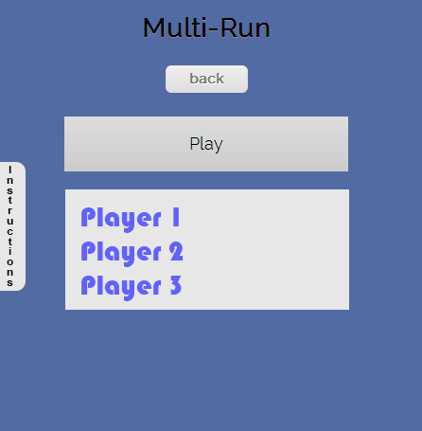
2. Users were also confused at first as to what they should do on the main menu. When presented with equally sized buttons (settings, create lobby, join lobby, profile), we concluded that it makes for a confusing user experience). We want our interface design to be easy to discern at a single glance. If we look at other successful apps. There is usually one big button or one egregious in color to give the user a visual clue as to what to press if they have no idea how to get started. We will change the settings to a gear icon that we can put in the top right area, and we can also move the profile button to the top right next to the settings. This is more in line with standard design and will make more sense to the user. We should also change the “profile” text to the user’s name. That way the user knows exactly who is signed it. Hopefully with these changes implemented, users will no longer be confused on the menu screen and will know quickly what to do and where to access everything in a cleaner and more user-friendly interface.
3. Also user feedback told us that it wasn’t necessary to display a login successful message to users and that the app should just login directly when provided with correct authentication. We removed login feedback accordingly and we also replaced the alert() box with a more user friendly self-effacing notification message. We still should probably tweak the visuals of the notification message and make it more color neutral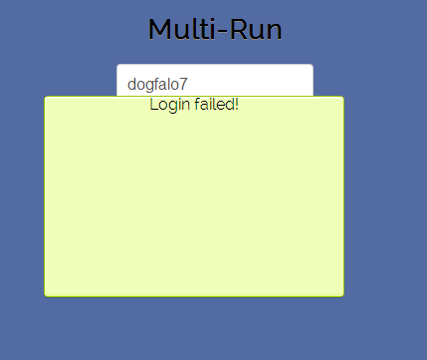
4. There were also some viewport display issues on different devices. This we are still looking in to and testing on different devices to make sure the interface in consistent across these devices
5. Users also encountered some gameplay bugs where the user could jump more than once, this is fixed as we added a check to see if user in in the air before allowing them to jump again. We check onFloor() == true before making the user jump
6. Some users reported that they really enjoyed the gesture input that the game centers around. It provided a way of input that was more interactive than just pressing a button on the screen. Some users wished that there was some type of feedback that told them whenever a gesture was inputted. We don’t have audio yet, but we think that some simple sound effects would ameliorate this problem.